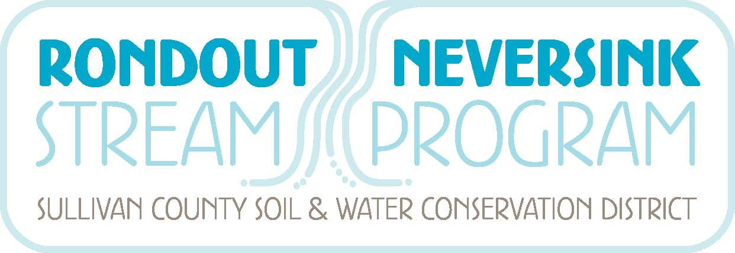

Denning Neversink Local Flood Analysis Committee Members

Mark Boncek, Denning
Bill Bruning, Denning
Brian Brustman, Sullivan Co SWCD
Wendell Buckman, Barton & Loguidice Engineers
Stacie Howell, RNSP
Shaun McAdams, Barton & Loguidice Engineers
James Stangel, Neversink
Keith Stryker, Neversink
Karen Rauter, RNSP
Mark Vian, NYC DEP
Greg Vurckio, Denning
Updated August 24, 2015

